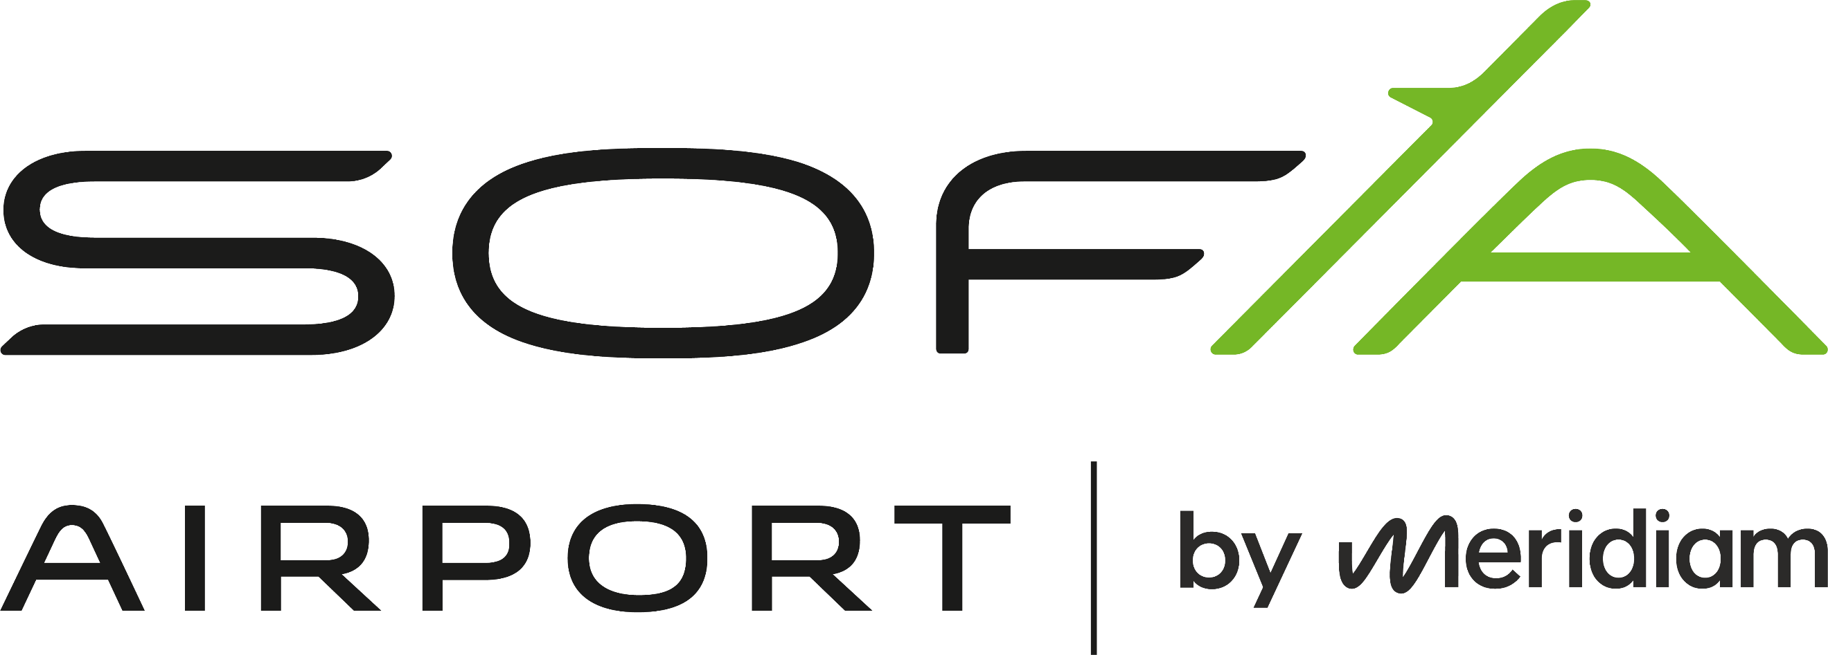
Regular Member


AIRPORTS COUNCIL
INTERNATIONAL
„СОФ КЪНЕКТ“ EАД

VISIT PERMIT

1. NAME: _____________________________________________________________________________
/forename, middle name and surname/

2. EGN/PFN 3. PLACE OF BIRTH: ____________________
/foreign citizens fill in date of birth/

4. CITIZENSHIP________________________

5. ADDRESS: ___________________________________________________________________________

6. I hereby declare that the information given above is correct. I am aware I bear criminal liability under Bulgarian law for declaring incorrect data, and this may result in a refusal to be issued a permit or an invalidation of a previously issued permit.

7. I hereby give my consent for the data included in this application to be used, processed and stored in a database by the competent authorities of the Republic of Bulgaria for the purposes of the permit. I am informed about the circumstances under Art. 19, para. 2 of the Personal Data Protection Act. I am aware of the sanctions that may be applied upon my failure to comply with Art. 143, para. 4, item 3 and item 4 of the Civil Aviation Act.
__________________ _______________
/signature/ /date/

8. Grounds for permit issuance: ______________________________________________________
/ Ref. Letter No or Report No/
TO BE COMPLETED BY THE AUTHORIZED SIGNATORY FROM ITEM 9 TO ITEM 12 INCLUSIVE

9. ESCORTING PERSONS: _______________________________________________________________
/persons with valid Sofia airport access permits with special mark giving escorting rights/

10. PHONE NUMBERS OF ESCORTING PERSONS: __________________________________________

11. __________________________________________/applying company, stamp/

12. __________________________________________ _________________
/name and signature of the person authorized by applying company’s specimen/ /date/
on behalf of SOF CONNECT –according to an order of the CEO of SOF CONNECT - EAD

13. CONTRACTOR COMPANY: ___________________________________________________________

14. In accordance with his/her job description and his/her duties, the individual will visit the following Sofia Airport areas using the following entries:

ENTRIES: 1-□ 3-□ 5-□ 6-□ 7-□ 8-□ APPROVED BY:
AREAS: D-□ H-□ K-□ R-□ T-□ Ta-□ Td-□ AUTHORIZED PERSON
N1-□ N2-□ /according to an order of the
СЕО of SOF CONNECT - EAD /
DATE: _________________
YES □ NO □
_________________
/SIGNATURE/

бул. „Христофор Колумб“ №1, София 1540
тел: 02 937 2055; 02 937 2056 факс: 02 937 2010; 02 945 9051
e-mail: public@sof-connect.com
sofia-airport.eu
SITA: SOFLDXH
SOF CONNECT - EAD
1, Christopher. Columbus blvd, Sofia - 1540, BULGARIA
Phone: (+359 2) 937 2055; (+359 2) 937 2056
Fax: (+359 2) 937 2010; (+359 2) 945 9051

e-mail: public@sof-connect.com
sofia-airport.eu
SITA: SOFLDXH

15. VALID FOR DATE: ________________________

16. PERMIT NUMBER: _________________________

17. PERMIT ISSUED BY: ________________________________________________________________
/name, surname, issuance date and signature/

18. PERMIT RECEIVED BY: ____________________________________ ____________________
/name and surname/ /date and signature/

19. PERMIT RETURNED BY: _________________________________ ___________________
/name and surname/ /date and signature/

INSTRUCTIONS
- TO BE ISSUED A PERMIT IT IS NECESSARY AN ACCOMPANYING LETTER FOR ISSUING A PERMIT TO BE SENT TO THE СЕО OF SOF CONNECT - EAD OR AN INTERNAL REPORT TO BE FILED CONTAINING DETAILED INFORMATION ON:
- THE GROUNDS FOR PERMIT ISSUANCE.
- THE TYPE OF ACTIVITY THE PERSON WILL PERFORM.
- LOCATION OF THE ACTIVITY IN THE SECURITY AREAS.
- THE APPLICATION FORM MUST BE PRINTED ON DOUBLE-SIDED PAPER AND ALL NECESSARY FIELDS MUST BE COMPLETED.

IN CASE ANY OF THE INSTRUCTIONS ABOVE ARE NOT FOLLOWED,
YOU MAY BE REFUSED AN ACCESS PERMIT.

